HIT IT App Tweaks Round 1
Wednesday 3-4-26

1-The Entry clicks cannot be the beginning of the calculation for the client’s day. Those points should clear out

2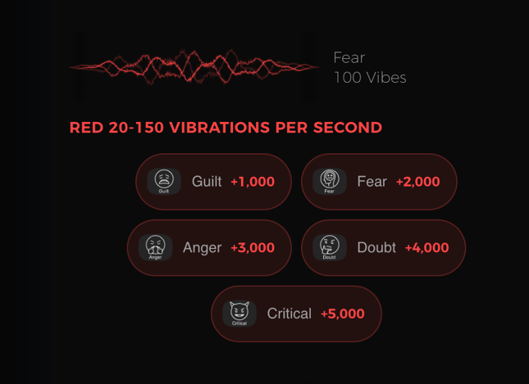

Please Make the:
Fear
100 Vibes

The next thickness – it is too light

2A-Replace the icons with the new ones supplied so they are
nice and large to the height of the areas

2B-Make the background of these Red buttons more of a very dark grey
so the RED color will pop better and be more legible.
2C-Add the button “Complaints” +6,000
(therefore this button will need function the same way as the other red ones do ie. description
And be added of course to the DAILY tallys

3-The nice motion vibrations you created are moving at the opposite speeds
Red is the Slowest then each color gets faster and faster – I like when they have lots of lines vibrating so you can use the RED type and just change the color and the speeds or use one other type like the blue and purple look – just if you can increase the speeds as they get to white the fastest

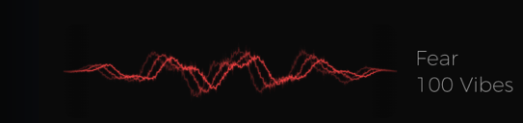

AND Please make the lettering ie. Enlightenment 700 Vibes the next heaviest weight
all these captions should be heavier

4
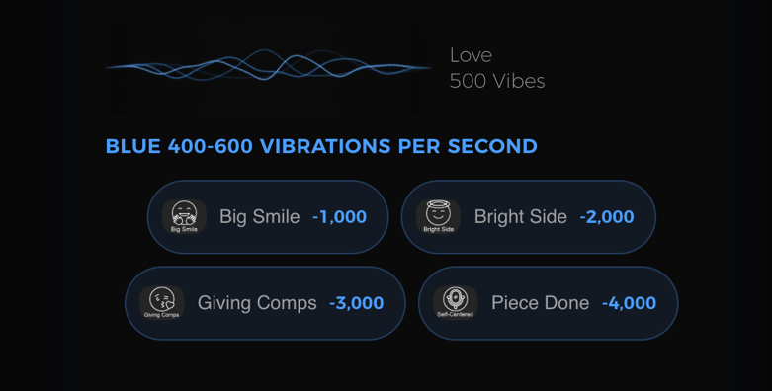

4A-All these buttons should behave the same way the RED ones do –
ie. when clicked on the field to describe what triggered this –
and that it will have a LOG IT button – this will be the case in all the following colored buttons.

4B-Now that I see that things just keep scrolling – I am adding/splitting 3 of the buttons as I am separating:
“Compliments” and “Giving” and adding “Grateful”

Please follow this new order and values:

“Bright Side” button set at -500 ADJUST THIS BUTTON’s Value

“Big Smile” button set at -1,000 Button Stays as is

“Compliments” button set at 2,000 NEW Solo BUTTON

“Grateful” button should be set at -3,000 NEW BUTTON

“Piece Done” button should be set at – 4,000 Stays the same

“Giving” button should be set at -5,000 - NEW Solo BUTTON

4C-Heavy up the “Love 500 Vibes” words

4D-New icons are being supplies

5 Greens are correct buttons – just make them with LOG IT function and heavy up the too thin text:
“Willing 310 Vibes” – and new icon replacements coming

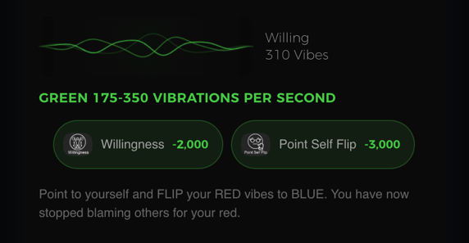

6-Purple and White – Simple – just like green – just make them with LOG IT function and
Heavy up the too thin text to the side of the vibration videos.

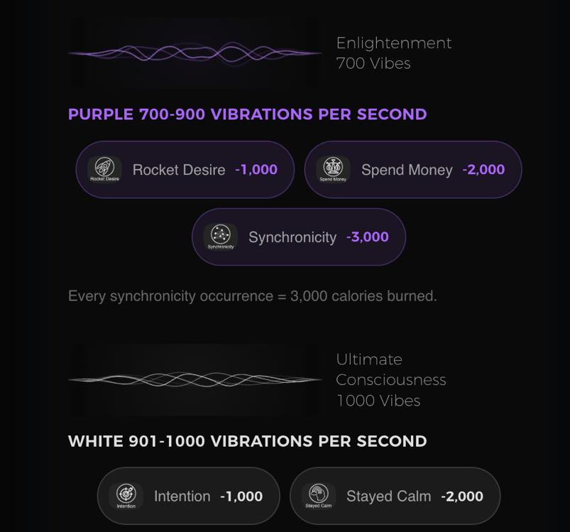

7 References Screen
Looking great – just add back in the 2 missing images AND update the Bold text under the PINS picture:

In the outside world it’s fact that 7 out of 10 People are Predominately RED,
2 are GREEN and Only 1 Consistently Vibrates BLUE.

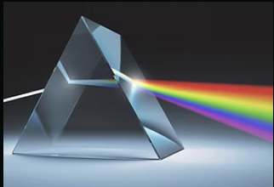
Label This “Prism”

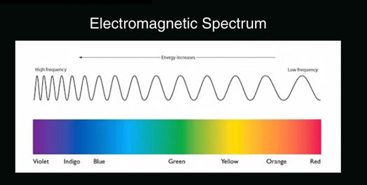

Keep this label:
Electromagnetic Spectrum (notice how this pic is not showing up)

8-Vibes

These were my notes about this page – and then I am going to tell you how to adjust the graphics and buttons on the screen.

Vibration Triangle Function notes
Hit It Your New Vibration Page Notes

This is an easy functioning page that once the user’s MIND Diet successfully gets their negative thoughts consistently down to 5,000 or less by use of the first 3 app pages – they now need to simply get their Vibrations up to 700 or 1000 to actually attract their burning desire/miracles

A pretty easy way to measure how someone is vibrating is to have the Drop Down Read all the vibes on the vibrational color triangle and select (3) Emotions per day from the check box listing (see below that I typed out the list) that they can check multiple selections – only (3). Then the number of vibrations will then be averaged out to reveal how they are vibrating that day.

Which 3 Emotions did you feel today:

1000 Ultimate Consciousness
700 Enlightenment
600 Peace
540 Joy
500 Love
400 Happy
350 Agreeable
300 Willingness
250 Determined
200 Courage
175 Pride
150 Anger
125 Anxiety
100 Fear
75 Grief
50 Lifelessness
30 Guilt
20 Shame

So this will be a drop down that the user can check the multiple (3) boxes
and then it would calculate the daily vibrational average level they are at.

The wording that says:

Positive High Vibrations 1s Milestone 600
(should be able to be set up to 1000)

The wording that says:

Which 3 Emotions did you feel today:
Is where drop down full listing should go

HERE’S HOW TO ADJUST THE SCREEN..

Delete these 3 buttons -
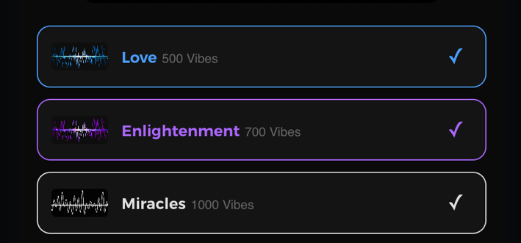

Go back to creating the screen just like this layout shows
The Blue the Purple the White are JUST reference graphics they do not have a function
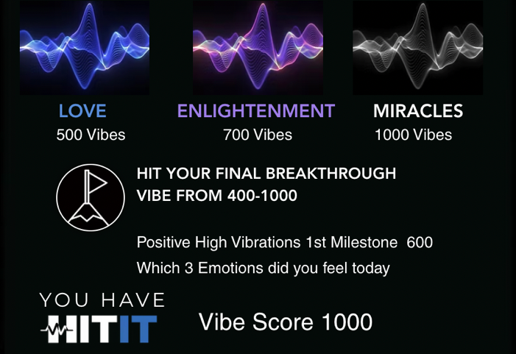

The statement to the right of the Flag is just a statement

The sentence:
Positive High Vibrations 1st Milestone “600” that number should be able to be set from 400 to 1000

The which Emotions did you feel today?

The buttons you have should all be deleted and they should be these 18 Buttons with just the
Vibe number and the Emotions Text Name. Please create these simple Text Only buttons.
You can do 3 buttons across and 6 rows deep:

20 Shame 30 Guilt 50 Lifelessness
75 Grief 100 Fear 125 Anxiety

150 Anger 175 Pride 200 Courage
250 Determined 300 Willingness 350 Agreeable

400 Happy 500 Love 540 Joy

600 Peace 700 Enlightenment 1000 No Resistance-Vortex

***Note an updated Triangle piece of art is attached to replace
The one that is there – because the white area wording
Has been updated

Now after all these selections (that you can make 3 Only)
The average appears as the:

Your Vibe Score (the daily one)

9-Exercises

First please fix the icons that were supplied within your uploaded folder from what’s on the left side to what is on the right side here:

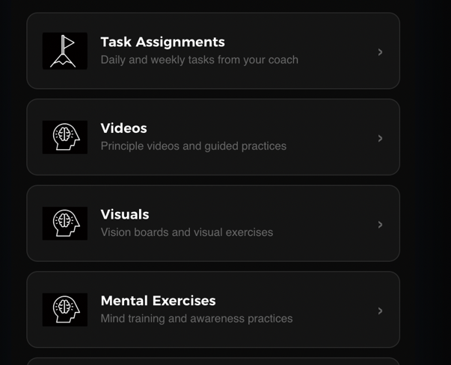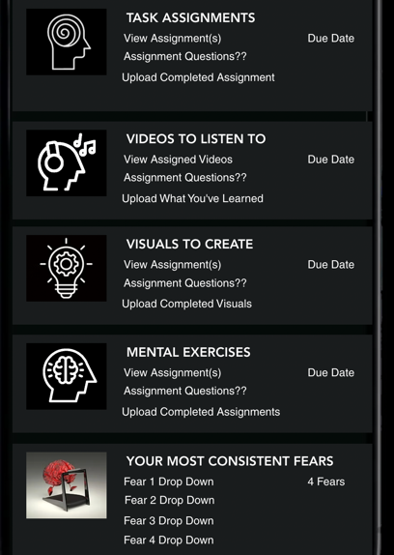

Next, I’m showing you how I send my assignments currently typed up as a word doc or directly into an email.

Then below in RED bold text – is the directions of how I envisioned the app to work

This is how I type up a task/exercise assignment now – 2 examples:

Action: Read Coach Jaynie's HIT IT Book (Available on AMAZON)
https://www.amazon.com/HIT-Coach-Jaynie-Jayne-Bierman/dp/1366327772
NO Need to buy the book - ATTACHED is your FREE PDF File Book Copy
Please Do NOT pass this onto others as per our agreement. This book takes just 30 minutes to read!
MARISA, PLEASE KNOW - that this IS a very SIMPLE way for me to introduce the VIBRATIONS concept that WILL DEFINITELY BRING FORTH the home run hit to the consistent joyful flow you are seeking!!! Please Read the Authors Intro and Review on this AMAZON page to understand the books concept:
https://www.amazon.com/HIT-Coach-Jaynie-Jayne-Bierman/dp/1366327772
Work to Do:
(A) Write a few paragraphs about what you gained an understanding of by reading this book.
(B) Select 4 of the Illustrations that made the most impact on you - make screenshots of those 4 and explain why they stood out to you (then attach the screen shots - so I'll be clear which images you are referring to)

Here’s a Video Assignment – How I explain it –
2 Examples from my word doc I currently send

Action: Hypnotic Affirmations - Listen to JESSE
Work to Do:
Listen to this very unique video
https://www.youtube.com/watch?v=za5nVIJKLRs
Start to Listen to this video track as you turn into go to sleep... leave it on... it repeats.... if you can use headphones that would be awesome...if not – keep the phone very close to you and have your power plugged into the phone so it doesn’t run out. If you miss the night then very first thing in the morning, listen to the track... (at least the first 20 Minutes - as the message repeats itself - and that's why it's best to turn it on at night so it will become part of your subconscious being).

SEND COACH JAYNIE A TEXT MESSAGE Each Day now in the morning on or before 10am saying "I listened to JESSE last night (or) this morning"

Exercises / Task Assignments SCREEN Notes

Task Assignment
This should be a field for me to write text about what they need to do
(Give me 4 fields)

And the me the coach and the client needs to be able to upload a Jpeg, Png, PDF, Powerpoint or Excel file

Either a file I am sending them to work from and thenA File that they created to complete the assignment and upload back to me

Video Strip
Where it says:
View Assigned Videos YOU SAID YOU COULD POPULATE THE VIDEO WITHIN THIS SECTION – That would be great
(this should be a DROP DOWN with multiple selection capability)
__ Video 1(this will be a space for Jayne to add a video link)
__ Video 2
__ Video 3
__ Video 4
__ Video 5

Upload What You’ve Learned
(this should be a DROP DOWN with multiple selection capability)

__ Video 1(need space for where Client can type text paragraphs)
__ Video 2
__ Video 3
__ Video 4
__ Video 5

Visuals to Create
This should be a field for me to write text about what they need to do
(Give me 4 fields)

And the client needs to be able to upload a Jpeg, Png, PDF,
Powerpoint or Excel file

Either a file I am sending them to work from and thenA File that they created to complete the assignment and upload back to me

Mental Exercises
Same structure as the Visuals to Create

This you did great – just make them 6 fields
Your Most Common Consistent Fears
These drop downs need client
and/or Jayne to enter custom information
AND Need a counter as to how many times
They keep thinking each and then a total
all to appear on the Summary Totals Page

The Blessings part is great as is

